Home page

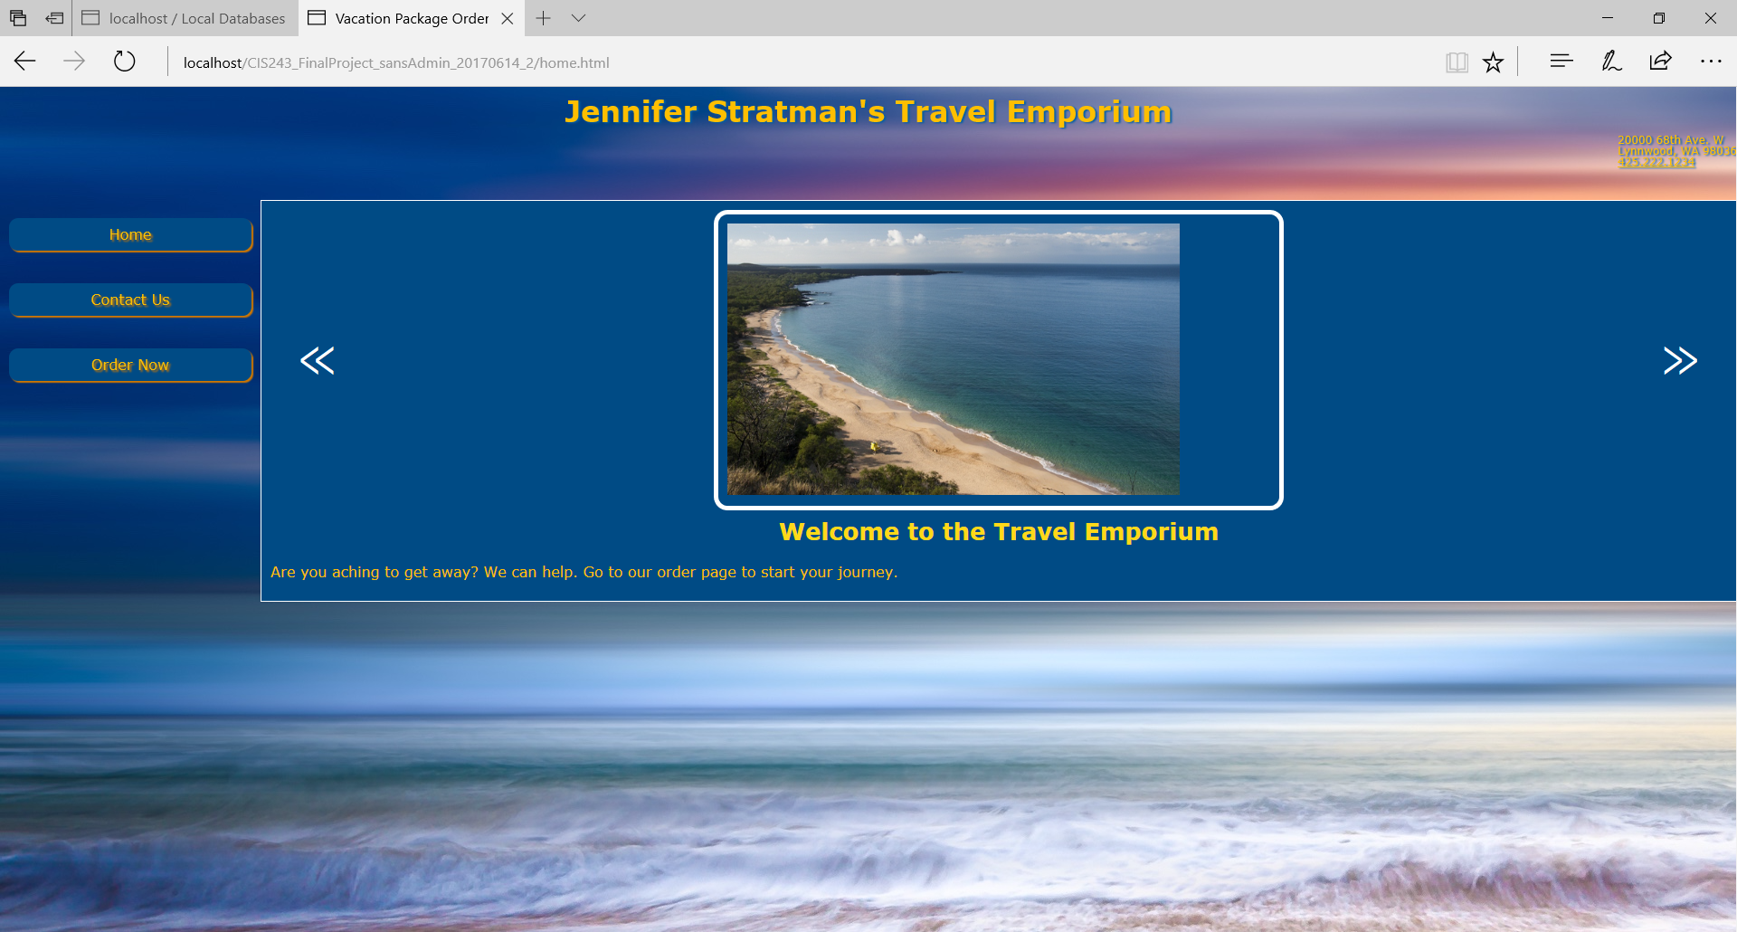

From the homepage, users can preview some of the amazing scenes they will see on their adventures. To contact us, go to the Contact page. To start your order, simply click “Order Now”.

Contact Us

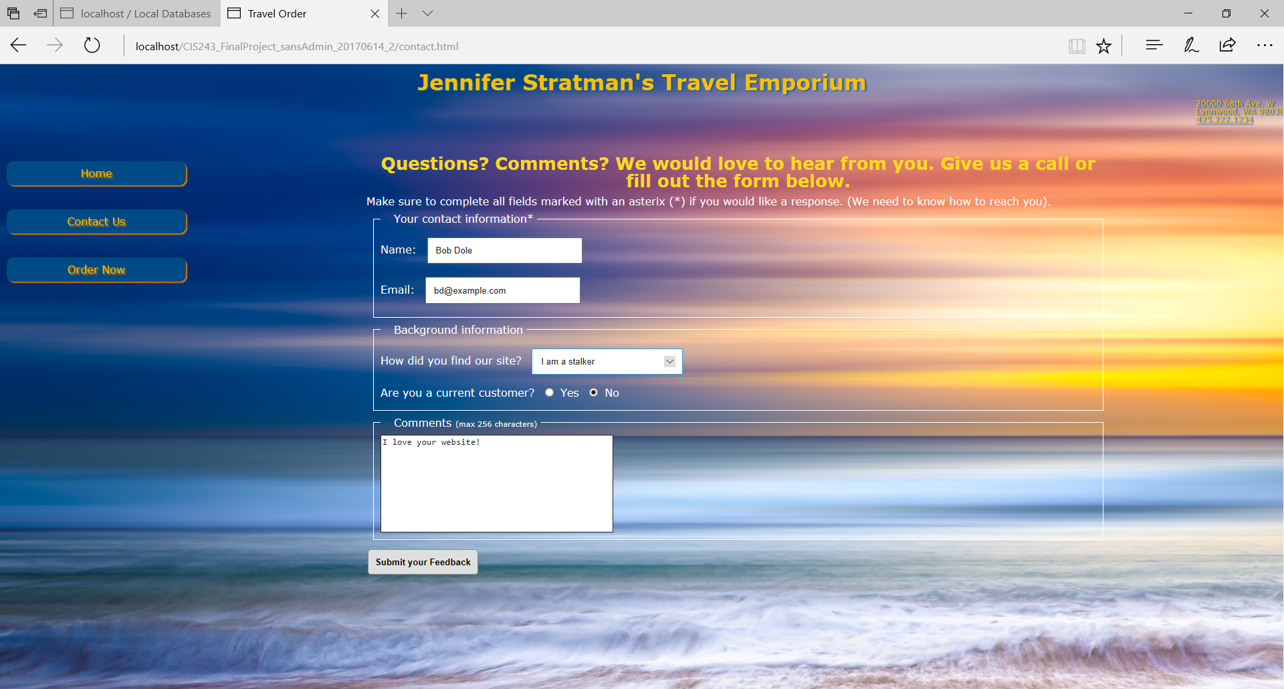

Go ahead and give us a call. Or you can fill out our contact form. You can leave anonymous feedback. If you want us to get back to you, please leave your name and email.

Thank you

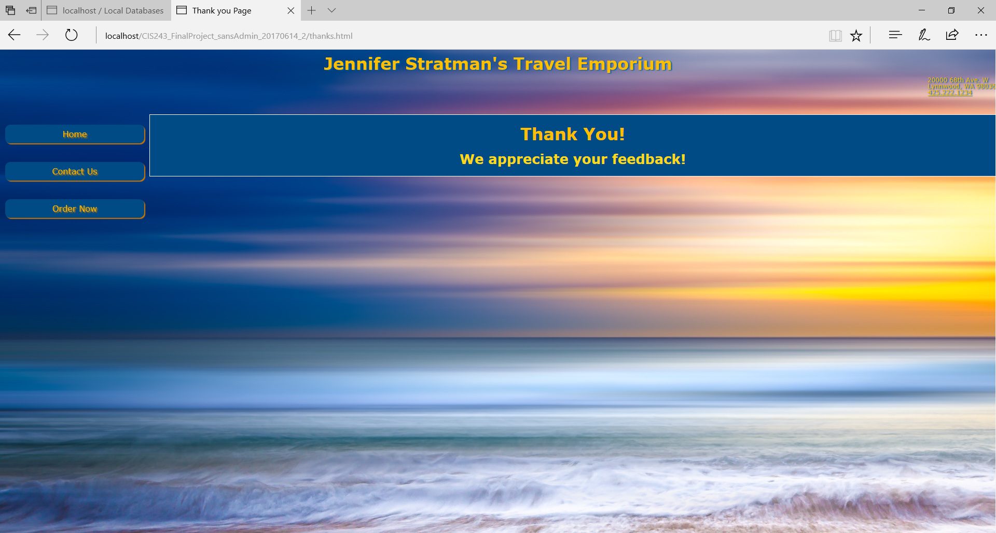

If your feedback submission is successful you will reach our Thank you page. From there, you can reach our home page, contact page, or order page.

Error page

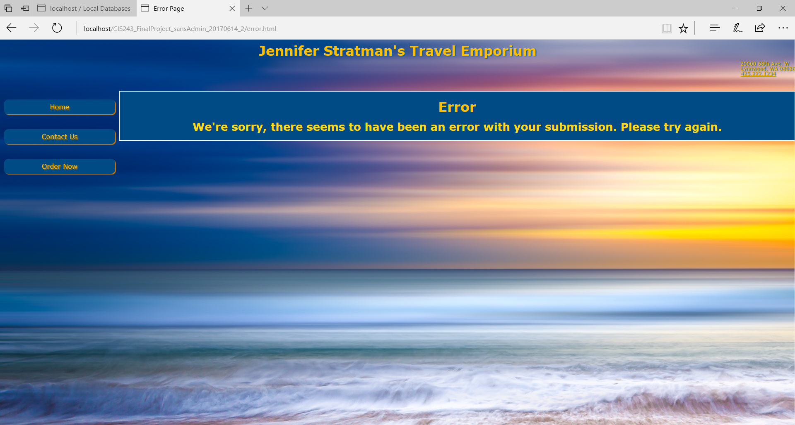

If, for some reason, there is an error in your submission, you will reach our error page. From there, you can reach our home page, contact page, or order page.

Order

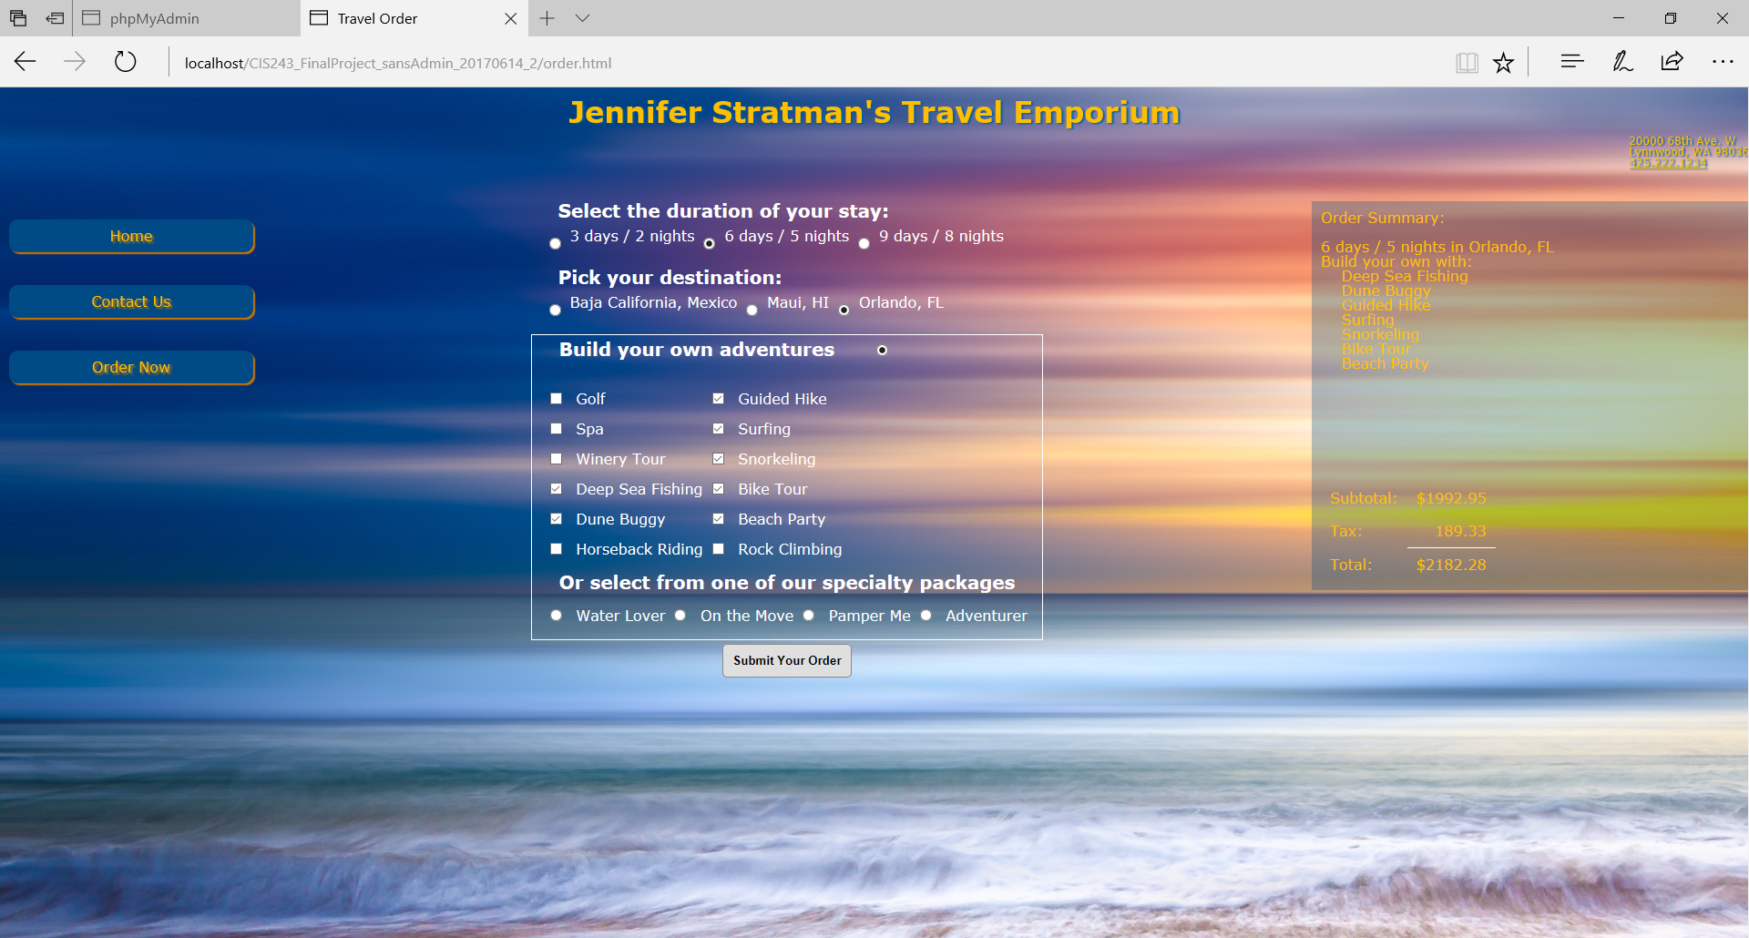

And the real reason you are here: to order your vacation! Just fill out the form and submit to start your order. Select the length of your stay, your destination, and your activities. You can customize which activities you will enjoy on your vacation or choose from one of four packages. A summary of your order, with your selections and amount due, will be displayed to your right.

Customer Information

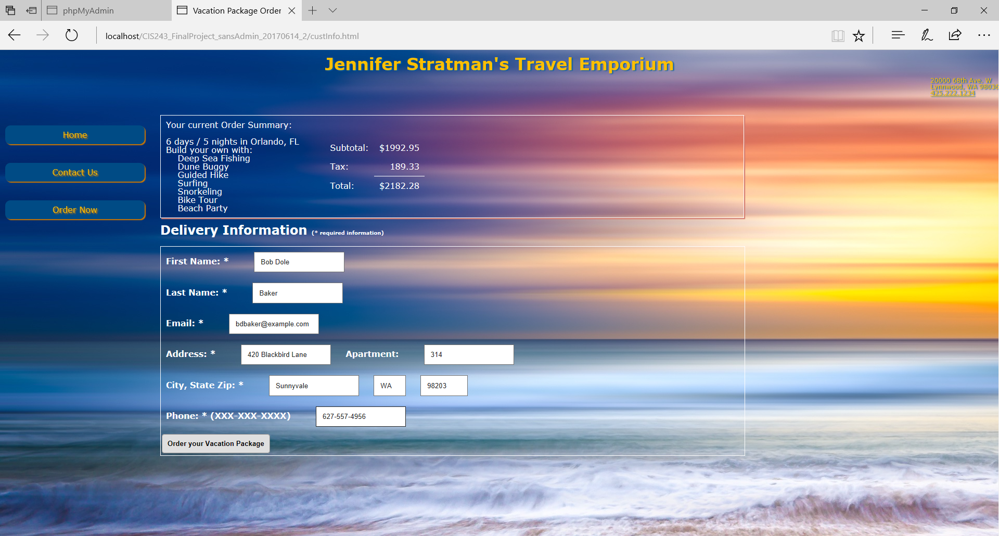

Once you submit your order, please provide your contact information for billing. Make sure to complete all required fields and click “Order your Vacation Package” to complete your order.

Summary

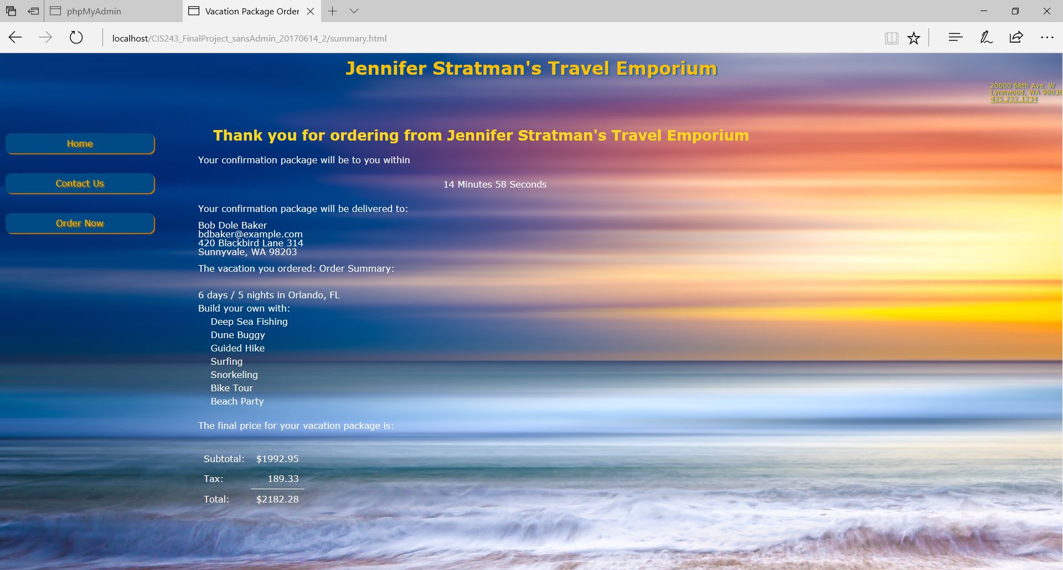

The summary page includes all information for your order. Please keep a copy of this page for your records. If you do not receive a confirmation email within 15 minutes of placing your order please contact us through our contact page or via phone. We appreciate your business.